About BrainSTEPS -The Brain Injury School Consulting Program
The BrainSTEPS Program was created to build a bridge connecting the medical, rehabilitation, education sectors and families following student (K-12) acquired brain injury (ABI). ABIs can cause cognitive, physical, socio-emotional, and behavioral impairments that impact classroom performance and learning. In 2007, the Pennsylvania Department of Health established the BrainSTEPS Program to address this issue. BrainSTEPS consulting teams support school teams in the development and implementation of educational plans following student ABI. The original BrainSTEPS model in PA is currently funded by the PA Department of Health and the PA Department of Education, Bureau of Special Education, and is implemented by the Brain Injury Association of Pennsylvania. In 2017, BrainSTEPS was recognized by the Centers for Disease Control (CDC) as a national model for educational consultation supporting students and school teams in the development and implementation of educational supports and services following an acquired brain injury.
If you are interested in more information about the
BrainSTEPS Program model, please contact:
Brenda Eagan Brown, MEd, CBIS
BrainSTEPS Program Coordinator
Email: eaganbrown@biapa.org
Phone: 724-944-6542

About BrainSTEPS
Pennsylvania's BrainSTEPS (Strategies Teaching Educators, Parents, and Students) Brain Injury School Re-Entry Consulting Program is in its 10th year of assisting school districts. BrainSTEPS was created by the PA Department of Health and is jointly funded by the PA Department of Health and Department of Education, Bureau of Special Education via the PaTTAN network. The Program is implemented by the Brain Injury Association of PA. We are happy to announce that during Fall 2016, the Colorado Department of Education adopted the BrainSTEPS model for statewide implementation.
Many students return to school with lingering effects that impact classroom performance. BrainSTEPS has been designed to consult with school teams and families in the development and delivery of educational services for students who have experienced any type of acquired brain injury. To date, BrainSTEPS has provided training and consultation to thousands of students and hundreds of schools in Pennsylvania.
Acquired brain injuries include any injury to the brain that is sustained after a period of development and includes all traumatic brain injuries (injury is caused by an external force and includes concussions) and non-traumatic brain injuries (strokes, tumors, seizures, aneurysms, etc.). BrainSTEPS works to not only re-enter students after a new brain injury, but with students previously identified as having a brain injury who may begin to develop educational effects over the years as the brain matures and develops.
BrainSTEPS is
- Considered a national model for brain injury educational consulting
- Comprised of 30 statewide consulting teams, consisting of education professionals, medical rehabilitation professionals, and family members
- All 29 educational Intermediate Units house a BrainSTEPS team
BrainSTEPS teams can:
- Provide various brain injury presentations to groups from educational, medical, and rehabilitation facilities in the community
- Consult with schools regarding identification, school re-entry planning, IEP/504 Plan development, intervention selection and implementation, long-term monitoring of students and other issues professionals face in supporting students with brain injury
- Monitor students annually until graduation for manifestation of new cognitive/behavioral/social issues
- Access additional support from the statewide Program Coordinator
Additionally, BrainSTEPS has trained over 1,300 Return to Learn Concussion Management Teams in districts across PA to monitor student academics and symptoms for the initial 4-6 weeks of recovery, prior to a BrainSTEPS referral.
To make a student referral to the BrainSTEPS Program, click on "Make a Referral to BrainSTEPS" link at the top of the page.
Brenda Eagan Brown, M.Ed., CBIS
Brain Injury School Re-Entry Program Coordinator
eaganbrown@biapa.org
(724) 944-6542

*Parents need to complete the step to enroll their student in BrainSTEPS
*Go to: https://www.brainsteps.net/
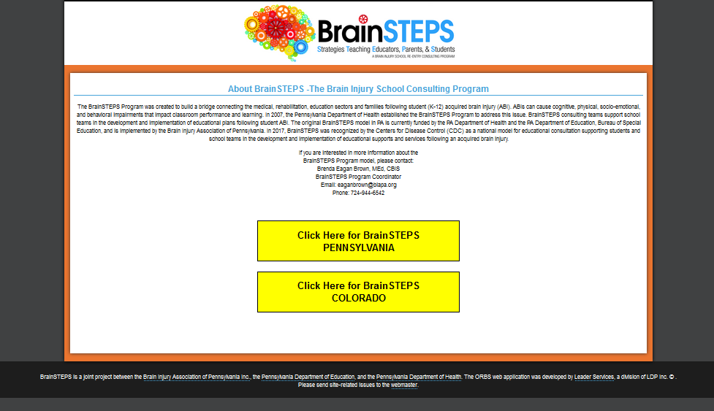
*Click on: Click Here for BrainSTEPS PENNSYLVANIA
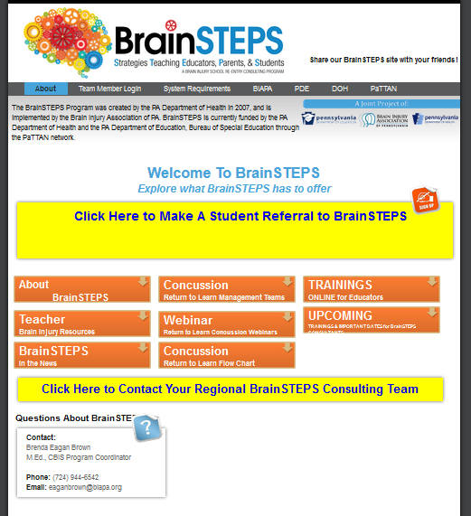

*Click: Click Here to Make A Student Referral to BrainSTEPS
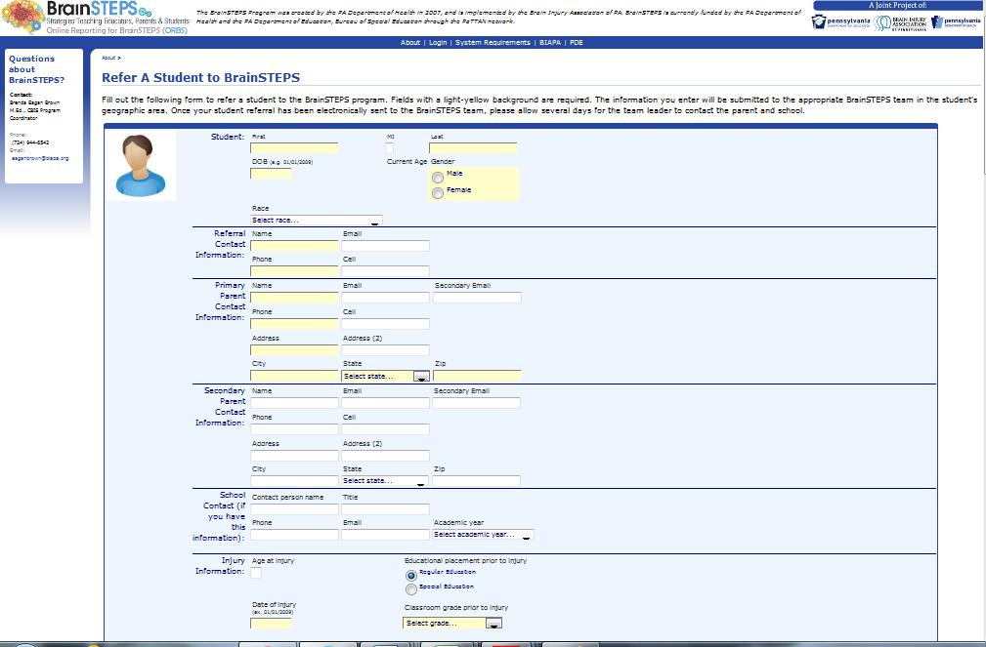
*Complete form and click “Submit Information”

